# Lab: Classes

Problems for in-class lab for the ["JavaScript Advanced" course @ SoftUni](https://softuni.bg/trainings/3588/js-advanced-january-2022). Submit your solutions in the SoftUni judge system at [https://judge.softuni.bg/Contests/2768/ Classes-Lab](https://judge.softuni.bg/Contests/2768/%20Classes-Lab).

## Person

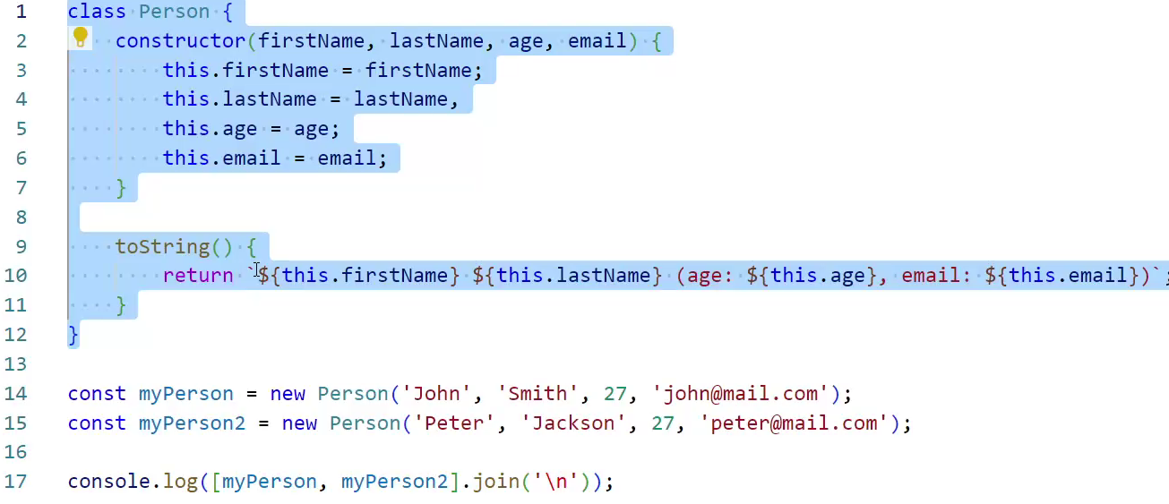

Write a **class** that represents a personal record. It has the following properties, all set from the constructor:

* firstName
* lastName
* age
* email

And a method toString(), which prints a summary of the information. See the example for formatting details.

### Input

The constructor function will receive valid parameters.

### Output

The toString()method should **return** a string in the following format:

**`{firstName} {lastName} (age: {age}, email: {email})`**

Submit the class definition as is, **without** wrapping it in any function.

### Example

|  |
| --- |
| Sample Input |
| let person = new Person('Anna', 'Simpson', 22, 'anna@yahoo.com');  console.log(person.toString()); |
| Output |
| Anna Simpson (age: 22, email: anna@yahoo.com) |

## Get Persons

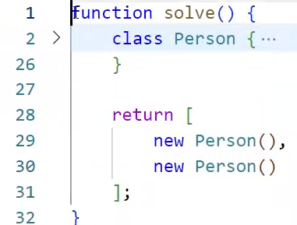

Write a function that returns an array of **Person** objects. Use the class from the previous task, create the following instances, and return them in an array:

|  |  |  |  |
| --- | --- | --- | --- |
| First Name | Last Name | Age | Email |
| Anna | Simpson | 22 | anna@yahoo.com |
| SoftUni |  |  |  |
| Stephan | Johnson | 25 |  |
| Gabriel | Peterson | 24 | g.p@gmail.com |

For any empty cells, do not supply a parameter (call the constructor with fewer parameters).

### Input / Output

There will be **no input**, the data is static and matches the table above. As **output**, **return an array** with **Person** **instances**.

Submit a function that returns the required output.

## Circle

Write a **class** that represents a **Circle**. It has only one data property - its **radius**, and it is set through the **constructor**. The class needs to have **getter** and **setter** methods for its **diameter** - the setter needs to calculate the radius and change it and the getter needs to use the radius to calculate the diameter and return it.

The circle also has a getter area(), which calculates and **returns** its area.

### Input

The constructor function and diameter setter will receive valid parameters.

### Output

The diameter() and area() getters should **return** numbers.

Submit the class definition as is, **without** wrapping it in any function.

### Examples

|  |  |
| --- | --- |
| Sample Input | Output |
| let c = new Circle(2);  console.log(`Radius: ${c.radius}`);  console.log(`Diameter: ${c.diameter}`);  console.log(`Area: ${c.area}`);  c.diameter = 1.6;  console.log(`Radius: ${c.radius}`);  console.log(`Diameter: ${c.diameter}`);  console.log(`Area: ${c.area}`); | Radius: 2  Diameter: 4  Area: 12.566370614359172  Radius: 0.8  Diameter: 1.6  Area: 2.0106192982974678 |

## Point Distance

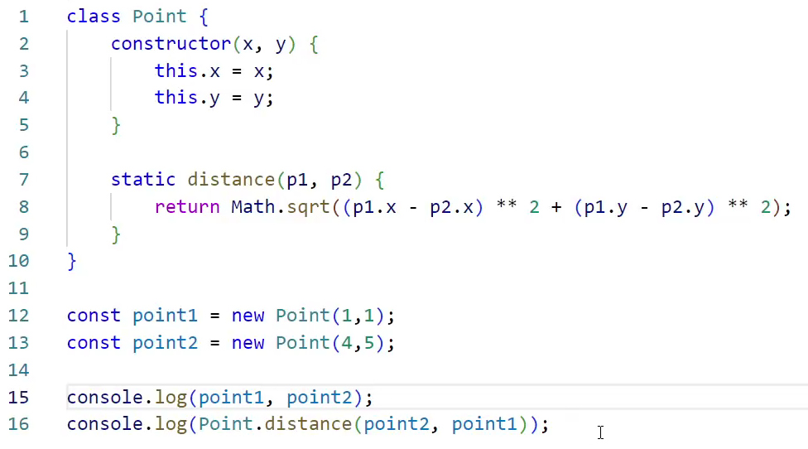–––

Write a JS **class** that represents a **Point**. It has **x** and **y** coordinates as properties, that are set through the constructor, and a **static method** for finding the distance between two points, called distance().

### Input

The distance() method should receive two **Point** objects as parameters.

### Output

The distance() method should **return** a number, the distance between the two-point parameters.

Submit the class definition as is, **without** wrapping it in any function.

### Example

|  |  |
| --- | --- |
| Sample Input | Output |
| let p1 = new Point(5, 5);  let p2 = new Point(9, 8);  console.log(Point.distance(p1, p2)); | 5 |